PARTICIPATION COST

OPTION 1 : Bare Space - Indoor
: Rate: RO. 115/- (U.S. $ 300/-) per sq.m.
(Minimum booking of 9 sq.m. and further booking in multiples of 9 sq.m.)

OPTION 2 : Shell Scheme

: Rate: RO. 135/- (U.S. $ 350/-) per sq.m.
(Minimum booking of 9 sq.m. and further booking in multiples of 9 sq.m)
(Note: The U.S. $ equivalents have been computed by rounding off to
the nearest 10 $ unit).

Shell Scheme Stall

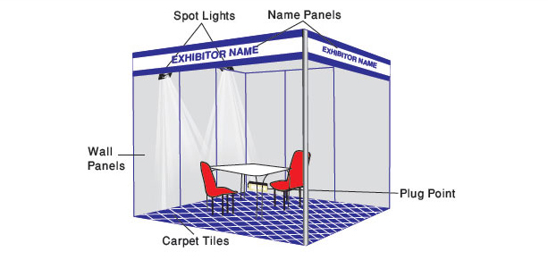

The shell scheme comprises of aluminum stands, each of 9 sq.m. with:

- White Panels of 1m in width, 2.5m in height and 3mm in thickness on the rear and sides.
- Carpet
- Fascia in English & Arabic (maximum 30 letters) (additional letters @ U.S $ 1/- per letter)
- One table and two chairs
- Two spotlights of 100 volts.
- One double socket (240 volts, 13 amps, single phase) and the electricity cost arising from
the use thereof.

